Use Cases and Logical Architecture

* **XID**: X00167867
* **Name:** Ahmed Abdallatif
* **Project Title:** Sneaker updates website

**Section 1: Use Cases:**

|  |  |
| --- | --- |
| Title | Adding Pages |
| Primary Actor | Admin |
| Story | The Admin will have access to the admin panel where he can add the new pages for the new categories created. The new Categories that are created in the admin panel will be user-friendly and to understand the context that is available to the reader. The new pages that are created will be connected to the other pages but will have a hyperlink just for that page. But will be on the one navbar for the user to easy navigate to it. |

|  |  |
| --- | --- |
| Title | Editing Pages |
| Primary Actor | Admin |
| Story | Since the admin is the only person that will have access to the admin panel, then he will be the only person to edit the webpages that are created and the categories or the details on webpages. Editing will can be used not only to update webpages but also to change any errors in the images or if the product image is in the incorrect category list. Once the editing is done, when the admin clicks the save button on the admin panel, the details that have been updated once the webpage has been refreshed. |

|  |  |
| --- | --- |
| Title | Navbar |
| Primary Actor | Admin |
| Story | The navbar will be created using the code studio and using the correct to add the webpages links that have been created to the navbar for the reader to navigate to the topic or the sneaker they want to detail about or the list of top sneakers. The navbar will also have to be assigned a CSS page which is where all the sizing and the font of the navbar will be customised to fit the webpage and make sure if the screen size is minimized then it changes the font of the screen |

|  |  |
| --- | --- |
| Title | Webpage Detail |
| Primary Actor | Reader |
| Story | The details that will be on the webpages created for the users to see will have many details but also images to back up the details that are been displayed to be easier to understand for the reader and the reader will know what is going on and understand exactly for example an image displaying the top 10 sneakers and talking about them. |

|  |  |
| --- | --- |
| Title | Images |
| Primary Actor | Admin |
| Story | Images that are going to be on the webpages and added to he different webpages, readers will understand what the text that is on the website explaining and help the reader understand for example image about the top 10 sneakers and helping him to understand what the text means to explain the reasons and why they are ranked that high. |

|  |  |
| --- | --- |
| Title | Social Links |
| Primary Actor | Admin, Readers |
| Story | The admin will list the link for all the social media that are linked to the updates of all the drops on sneakers and the lists that are being created for the top tier sneaker releases or overall shoes and this will be added via the code studio at the bottom of the webpage in a container to look eye catching and more formatted. For the reader they will be able to click the link to be redirected to the social media account which will also have updates on sneaker releases. |

**Section 2: Logical Architecture**

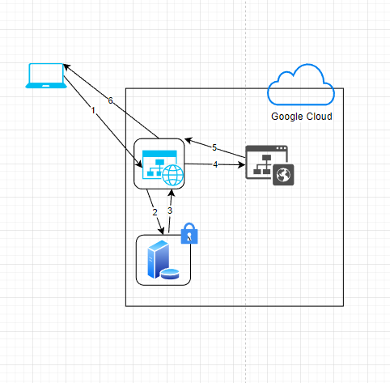

1. A user connecting to the website is the starting point. The user connecting to the website is called Connection 1. The database is accessed by the website to get information about the pages that need to be loaded. All of the information from the database is sent to the website. The directions and map to the website are given back to the user after the website gets the location of the user from the maps API.
2. WebPage to database
3. Database to webpage
4. Webpage to API
5. API to webpage
6. Webpage to User